# **Best Practices for Drupal CMS on Azure Websites.**

[Drupal CMS](http://drupal.org/) is an Open source Content management system written in PHP and use MySQL. Drupal offers a refined programming interface for developers; no programming skills are required for a basic website and installation. You can use Drupal to build everything from personal blogs to enterprise applications. It is a popular framework among government organizations as well. The primary focus of this blog post is to articulate how to run Drupal CMS websites on Azure Websites platform and in this process, you will learn:

* How to migrate existing Drupal site to Azure Websites
* How to setup Azure Storage Module for Media content
* How to improve with caching
* Use best practices for Drupal CMS
* Scale across regions

## **How to migrate an existing Drupal site to Azure Web Apps**

Migrating your Drupal website to Azure Web App is a fairly easy task. Just follow the steps below and you can move your entire Drupal site in an hour.

* Note: If your site uses a local Apache Solr search provider. Prior to uploading site data/files, you will need to change the Drupal container image to[**appsvcorg/solr**](https://hub.docker.com/r/appsvcorg/solr)
* . To change this navigate to your app service then find **Container settings** and change the **Image**(-See Below).

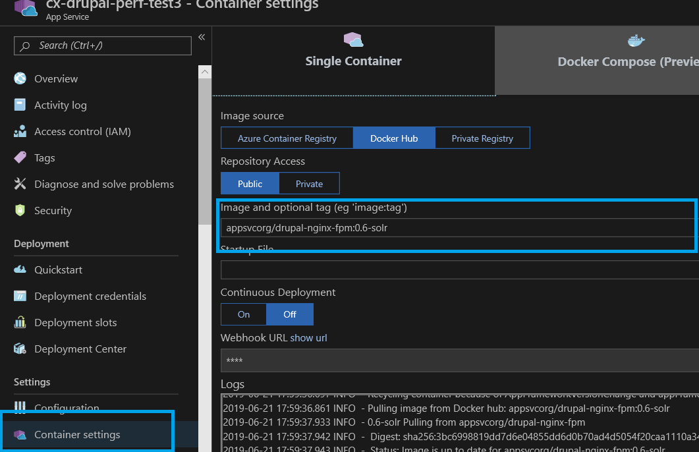

### **Create an Azure Web Site and MySQL database**

The simplest method to provision Drupal with MySQL is to use the Drupal on Linux Web App with MySQL. This creates a web app for containers instance that is preconfigured with the base Drupal application stack and database connections. You can begin creating a Web App by searching the marketplace or following this link: [Drupal on Linux Web App with MySQL.](https://ms.portal.azure.com/#create/Drupal.Drupalonlinux) Once your web app is created you can proceed with the next steps.

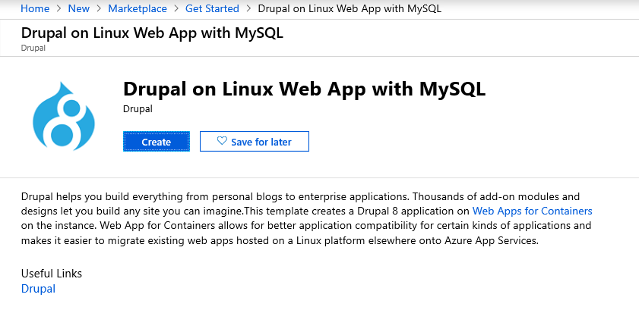

### **Copy database to MySQL in Azure Web Apps**

For most situations, a MySQL Dump and Restore can be used to migrate your MySQL database. This can be done through Command Line Interface or MySQL Workbench. For step-by-step migration instructions see: [Migrate your MySQL database to Azure Database for MySQL using dump and restore.](https://docs.microsoft.com/en-us/azure/mysql/concepts-migrate-dump-restore)

You first need to have to provide the username and password for your existing Drupal database. You also have to provide the hostname, username, password, and database name for the MySQL database you created in the first step. This information is available under the **Connection Strings** blade for the Azure MySQL database you just created. The connection string information should have a format similar to the following.

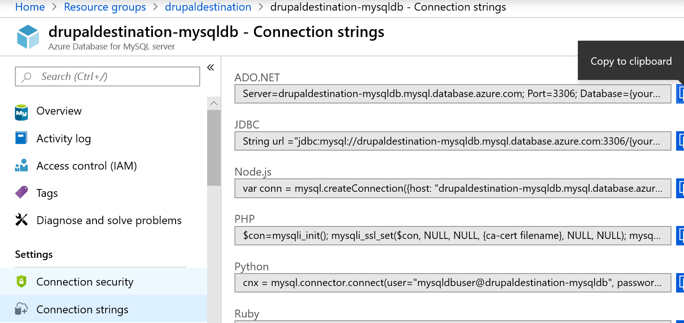

Depending on the size of your database, the copying process could take several minutes. Now your Drupal database is live in Azure Websites. Before you deploy your Drupal code, you need to modify it so it can connect to the new database.

### **Modify database connection info in settings.php**

Here, you again need your new database connection information. Open the **<drupalsite>/sites/default/setting.php** file in a text editor, and replace the values of 'database', 'username', 'password', and 'host' in the **$databases** array with the correct values for your new database. When you are finished, you should have something similar to this:

$databases = array ('default'=>array ('default'=>array ('database'=>'remote_db_name','username'=>'remote_username','password'=>'remote_password','host'=>'remote_host','port'=>'','driver'=>'mysql','prefix'=>'',),),);

**Note:** If you have a **$base_url** configuration parameter in your **settings.php**, comment it out since Drupal CMS will create the URLs from the value set for **$base_url**. You can use the **$base_url** parameter once you have your azure website configured to use the custom domain such as [www.exmaple.com](http://www.exmaple.com/) . Save the **settings.php** file. Now you are ready to deploy.

### **Deploy Drupal code using Git or FTP**

The last step is to deploy your code to Azure Web Sites using Git or FTP.

If you intend to use Git to publish your Drupal site, you may review the steps in the link below that explains how to configure a Git repository. See [Create a PHP-MySQL Azure web site and deploy using Git.](https://azure.microsoft.com/en-us/develop/php/tutorials/website-w-mysql-and-git/)

* If you are using FTP, get the FTP hostname and username from your website's dashboard. Then, use any FTP client to upload the Drupal files to the **/site/wwwroot** folder of the remote site.
* If you are using Git, you should have set up a Git repository in the previous steps. You must install Git on your local machine. Then, follow the instructions provided after you created the repository. Review this [article](https://azure.microsoft.com/en-us/documentation/articles/web-sites-php-mysql-deploy-use-git/) for configuring Git

## **How to improve performance with caching**

Websites that receive massive large amounts of user traffic (hundreds of thousands to millions of page views and unique visitors) will benefit from the use of a caching with Redis cache. For more information on available caching solutions see [Best practices for cloud applications: Caching](https://docs.microsoft.com/en-us/azure/architecture/best-practices/caching). The general approached for caching is having a mix of Content Delivery Network (CDN) and backend cache ( Redis ) service. Drupal uses the database to store cache. If any content is modified then Drupal detects this change and expires the cache hence maintaining content consistency. Redis replaces Drupal's internal caching system. You can also use [Varnish as Front end cache](https://azure.microsoft.com/en-us/blog/using-varnish-as-front-end-cache-for-azure-web-apps/) instead of a CDN to significantly improve performance.

## **Use Best Practices for Drupal CMS**

A common practice for any website on the cloud is to

1. **Plan for the future:** You must track the performance and requirements of your website and user traffic patterns to be able to project when you need to scale up or scale down your infrastructure or modify your infrastructure to meet your latest requirements
2. **Backup your site:** Backup both your website and the database. Test your backup and restore procedures.

Now let's focus on Drupal CMS and learn some of the best practices for building and managing Drupal CMS on Azure websites:

### **Security configuration:**

1. Remove sensitive temporary files while you edit files, this may create temporary backup files such as file ending with .bak, ending with a ~ character, **settings.php.orig** . These files are viewable in a browser if you haven't restricted it in **the web.config** using URL rewrite rules. This can lead to attackers gaining access to critical information. Remove any such files present in the website. This can be solved by adding the URL rewrite rules in web.config to deny access to any of these files or you can automate this by using a simple web job that looks for these files and deletes them automatically.
2. Enable SSL for login Drupal does not require the use of Secure sockets layer (SSL), when users log in. Hence it makes it easier for attackers to gain administrative access to your website. Install and enable the [Secure Pages](http://drupal.org/project/securepages) module from drupal.org. This module can ensure that any/user URLs are served using SSL.
3. Disallow unsafe file uploads and image fields allow users to upload files. A malicious user can use this to gain control of your website by uploading a file that can cause havoc on your system. Restrict what file types are support for file and image uploads and remove any extensions like .exe, .swf,.flv,.htm,.php,.vb,.vbs
4. Enable Security Kit module: The Security Kit module provides useful security enhancements to your website such as Clickjacking, Cross-Site Request Forgery (CSRF), and Cross-Site Scripting (XSS) protections among others. This module's default configuration is recommended but If your website has some special requirements that this module may block, review the configuration and update as desired. To learn more, see [Security Kit module](https://drupal.org/project/seckit).
5. Do not use common admin usernames, your admin username (User ID 1) should not be **admin, administrator, and root** which are commonly used and can represent a security vulnerability to your website. Use complex or unique usernames to avoid exploits.
6. Hide Site errors from end-user, These error messages can reveal sensitive information about your website and its server to site visitors. To configure your website to not display error messages for users, on your website, open the Logging and errors page at /admin/config/development/logging, select None from the Error messages to display section, and then click Save configuration.
7. Enable The Password Policy module Content editors for your websites may use simple passwords for their login credentials and which in turn can open doors to attackers to exploit. To reduce the vulnerability here, enable [the Password policy module](https://drupal.org/project/password_policy) to enforce strict password policies.

### **Performance configuration**

1. Page cache max-age less than 5 minutes with a page cache max-age set to less than 5 minutes, the server has to frequently regenerate pages. This can decrease your site's performance. To set the page cache max age to 5 minutes or more, on your website, open the Performance page at /admin/config/development/performance, and then select a new value from the **Page cache max-age** drop-down.
2. Optimize CSS and JS scripts with CSS/JS optimization disabled, your website visitors are experiencing slower page performance and the server load is increased. To enable CSS optimization, on your website, open the Performance page at/admin/config/development/performance, and then select Aggregate and compress CSS files. To enable JavaScript optimization, on your website, open the Performance page at/admin/config/development/performance, and then select Aggregate JavaScript files.

### **Azure website configuration**

1. Enable Web server logging and use a Storage account to store the logs. You can reuse the same storage that you have set up for media content. For more information, see [Azure website diagnostics](https://azure.microsoft.com/en-us/documentation/articles/web-sites-enable-diagnostic-log/).
2. Setup auto-scale which will scale up or scale down your website based on the traffic and load on your website dynamically. For more information, see [Auto-scale Configuration](https://docs.microsoft.com/en-us/azure/architecture/best-practices/auto-scaling).
3. Choose the appropriate app service tier to support your workload. Basic or Standard mode will give you dedicated VM instances to run your website for better performance. For more detailed information, see [Features by tiers](https://azure.microsoft.com/en-us/pricing/details/web-sites/).
4. Configure the site to use at-least 2 Medium or Large instances (instance refers to a VM that is abstracted for your website). If you use a single instance, if the instance goes into a bad state then your site will be down. Using 2 instances will avoid this single point of failure.
5. Load test your website using tools like Visual Studio Load test tools or [Load test with the Azure portal](https://docs.microsoft.com/en-us/azure/devops/test/load-test/app-service-web-app-performance-test?view=azure-devops) to make sure your scale at which you configured your site actually handle your website traffic.
6. Setup Auto-healing for your website which recycles your VM instances based on a condition. For more information, see [How to Auto-heal your website](https://azure.microsoft.com/blog/2014/02/06/auto-healing-windows-azure-web-sites/)

### **Coding practices**

1. Avoid changes to Drupal core if possible Making changes to the Drupal Core will make it harder to manage version updates for Drupal on your website and will be difficult to maintain as your website grows.
2. Avoid using too many modules Drupal gives you're the flexibility to add modules to extend the feature set of the CMS, but too many modules can impact the performance of your site and make it slow.
3. Include a web.config to run on Azure websites uses IIS, and hence add a web.config with the configuration below to protect unauthorized access to files and manage clean URLs. Use the sample web.config for a Drupal website as shown [here](https://groups.drupal.org/node/25421). You should disable Application Request Routing cookie which pins a user's subsequent requests to a specific instance if enabled. Disabling it will allow your website to use the normal load balancing behavior of the platform. To learn more, See [Disable ARR Cookie](https://azure.microsoft.com/en-us/blog/disabling-arrs-instance-affinity-in-windows-azure-web-sites/). To do this in your web.config file add the following section under **<system.webserver>**

<httpProtocol> <customHeaders> <add name="Arr-Disable-Session-Affinity" value="True" /> </customHeaders> </httpProtocol>

## **Scale Drupal across multiple regions**

By hosting a Drupal website across multiple regions you mitigate the risk associated with a single point of failure when you have a single website running in one data center. A key thing to remember with Cloud solutions is that you need to assume that every component (website, database, cache, etc.) may fail and make your solution resilient. This will reduce any operational costs incurred due to service outages that form a part of your infrastructure. For this scenario, you need to host your Drupal website in at least two regions, say we choose East US and West US region. See the figure shows an Active-Active (Master-Master) website configuration for Drupal Website:

1. Two Azure Websites linked to their respective MySQL databases
2. Both MySQL databases are synchronized with database replication
3. Azure Traffic Manager to load balancing end-user traffic based on Performance.
4. Managed Redis service.
5. Azure Storage (Geo-redundant) with Azure CDN

This architecture is fairly simple to create, but if your application has special requirements, then are you can tweak the above configuration to meet your needs. You can update this configuration:

* create a Master-Slave website configuration
* create one master and multiple-slaves website configuration
* use custom replication processes using Web Jobs
* automate management processes using Web Jobs

### **Scaling the Web Site**

Scaling up on Azure Web Sites involves two related actions: changing your Web Hosting Plan mode to a higher level of service, and configuring certain settings after you have switched to the higher level of service. Both topics are covered in this article. Higher service tiers like Standard mode offer greater robustness and flexibility in determining how your resources on Azure are used. For more details, see [How to scale Azure website](https://azure.microsoft.com/en-us/documentation/articles/web-sites-scale/).

### **Scaling the database**

Your application depends on two components which are the Azure website and the database. To be able to scale your database for high availability and disaster recovery for your database there are many options depending on how to create your database. For example, here are two scenarios :

1. Azure Database for MySQL offers database replication across region pairs (example: East US and West US ) See: [Replicate data into Azure Database for MySQL](https://docs.microsoft.com/en-us/azure/mysql/concepts-data-in-replication)
2. You may also set up a [MySQL Cluster CGE](http://www.mysql.com/products/cluster/) which gives you all the tools to manage a MySQL Cluster on an Azure Virtual Machine. Note that in this case, you will be manually managing all the MySQL clusters, database replication, and scale operations.

### **Scaling your Redis cache**

Azure Redis cache scaling feature is currently in preview. Azure Redis cache has different cache offering which provides flexibility in the choice of cache size and features. You can scale the size of the cache using **the Change pricing tier** blade in the [Azure portal](https://portal.azure.com/). To learn more on how to scale your cache, click [here](https://azure.microsoft.com/en-us/documentation/articles/cache-how-to-scale/).

### **Setup Traffic Manager to route your user traffic**

Azure traffic manager allows you to control the distribution of user traffic to your specified endpoints, which can include web sites. Traffic Manager works by applying an intelligent policy engine to Domain Name System (DNS) queries for the domain names of your Internet resources. Your cloud services or web sites can be running in the same data center or in different data centers across the world. For a comparison of the available routing, methods see [Traffic Manager routing methods.](https://docs.microsoft.com/en-us/azure/traffic-manager/traffic-manager-routing-methods)

* **Performance**: Select *Performance* when you have endpoints in different geographic locations, and you want requesting clients to use the "closest" endpoint in terms of the lowest latency. For more information, see [Performance load balancing method](http://msdn.microsoft.com/en-us/library/azure/dn339010.aspx).

Create a new Azure Traffic Manager Profile service endpoint from Azure Management portal 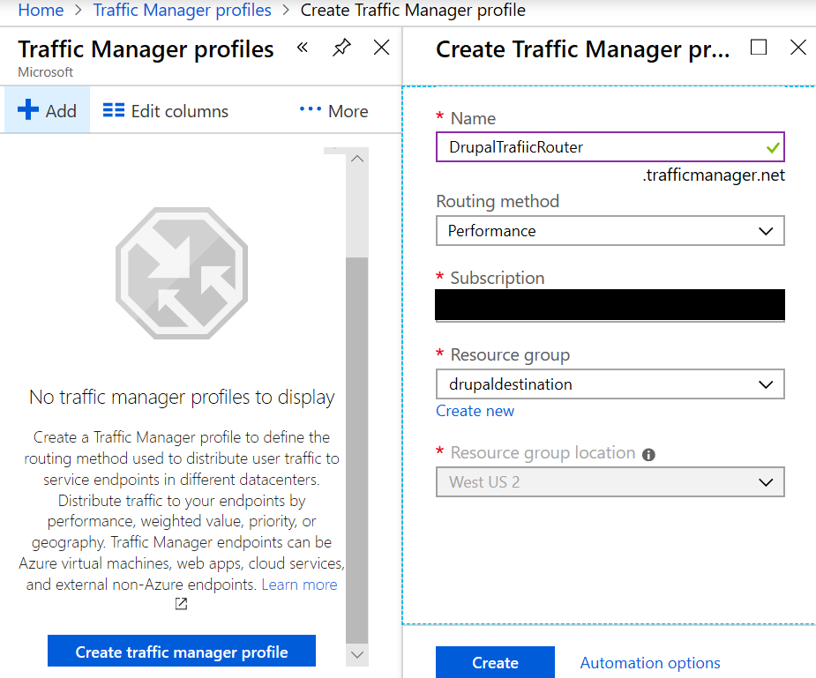Once the resource is created, Now access your dashboard for traffic manager profile and open **Endpoints** and click on ADD to configure it to use the websites you want to route the traffic to. 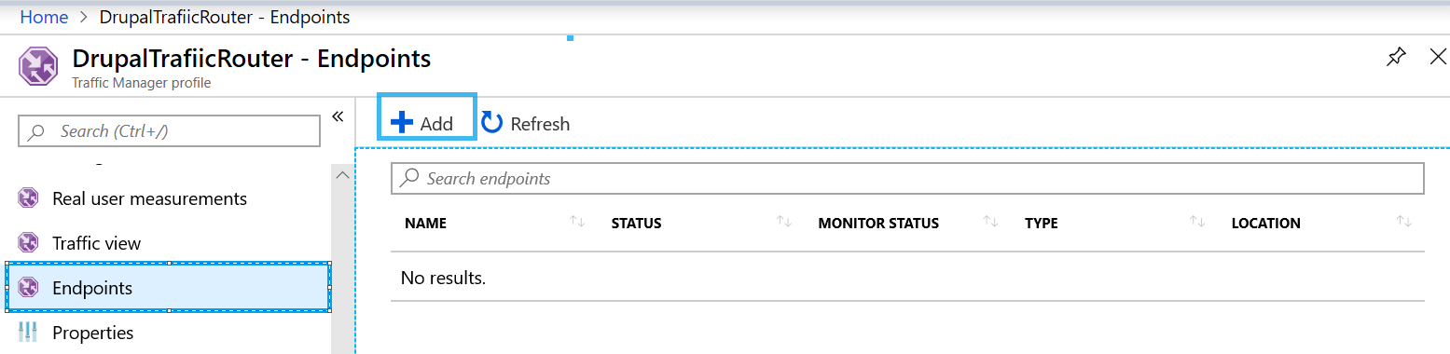In the **Add** dialog box, select Service type as **Azure Endpoint,** Target resource type as **App Service** and choose the websites you want to route the user traffic to from Target resource. 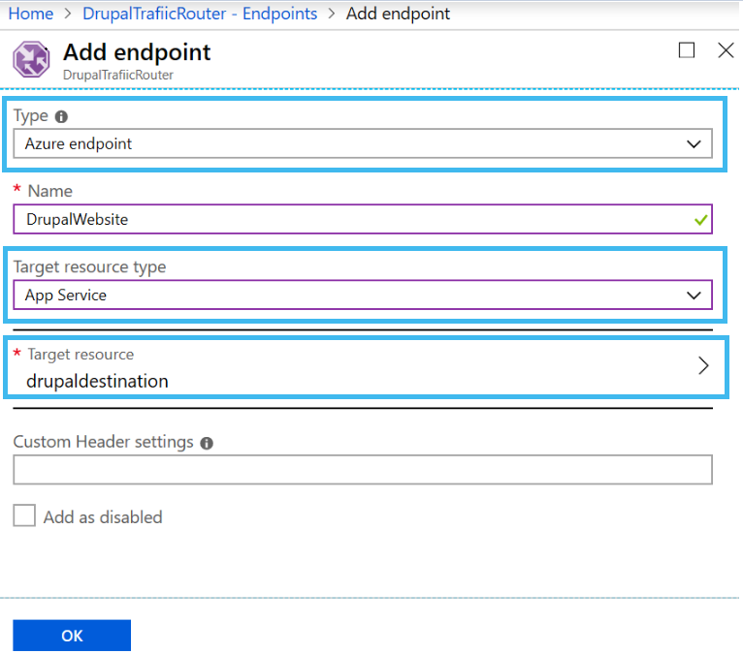Now you can see that our endpoint is added to the traffic manager.

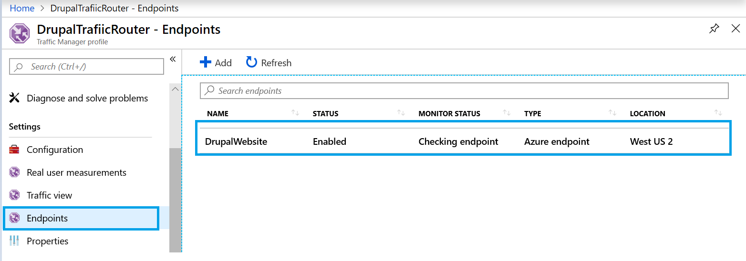

You can browse the traffic manager URL from the Overview tab and you will see that the traffic is being routed as per your configuration

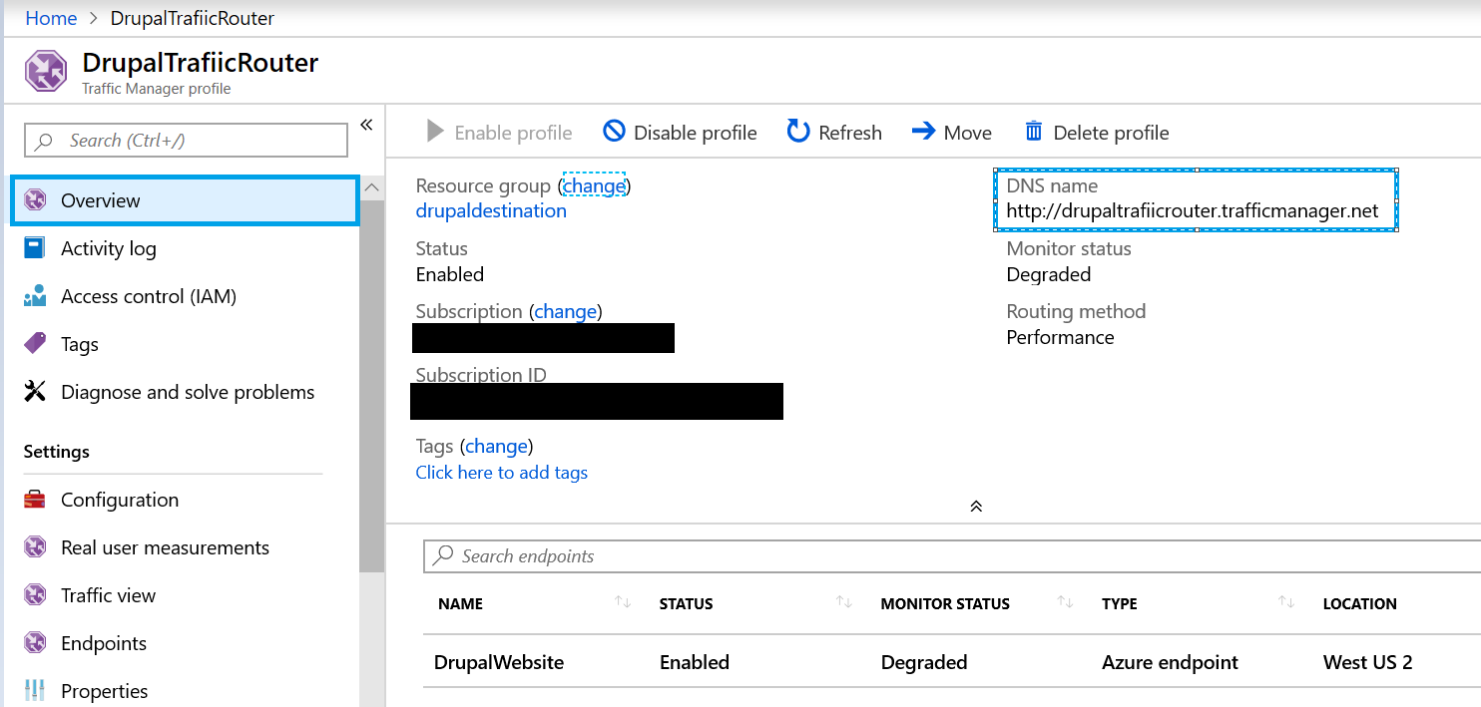

## **Wrapping it up!**

We have covered the basic tasks and concerns involved with moving a Drupal website to Azure Websites. The solutions discussed above will make migration and configuration of your Drupal websites on Azure websites service easier irrespective of whether your Drupal site is small or large. Now let's start building and scaling your Drupal websites on Azure websites platform.